# Skill and Chance: Revitalising Noughts and Crosses.

## Game Premise

Within this session by team worked together to create take the brief to “modify the traditional game of ‘Noughts and Crosses’ by introducing elements of chance-based mechanics whilst resembling the game.”

The premise of our game was make a team based Noughts and Crosses themed game which would use additional shape tokens (See Fig 1) and in order for the player to place a token on the board – there are two different board styles the players could chose to play on (see Fig 2 and 3) they would need to answer a trivia question based one of the six categories (See Fig 4) which would be read from a trivia card (See Fig 5).



Fig 1, Game Tokens.

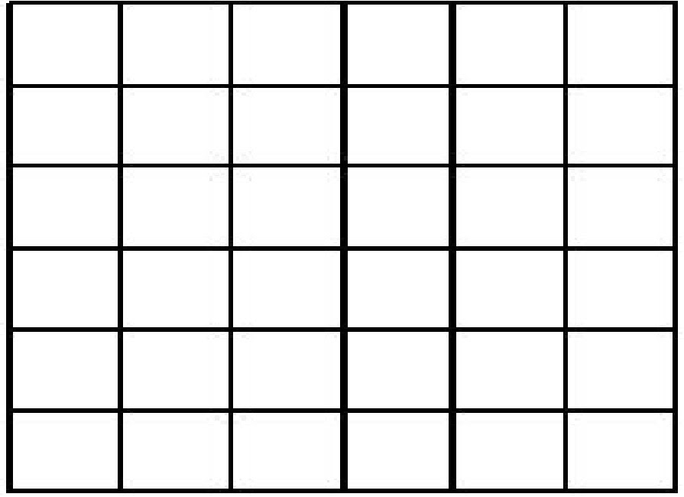

Fig 2, 6x6 Game Board.

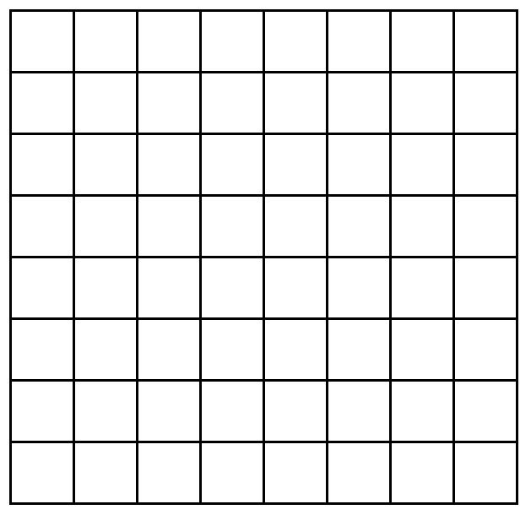

Fig 3, 8x8 Game Board.

1 - Geography

2 - Entertainment

3 - History

4 - Arts and literature

5 - Science

6 - General

Fig 4, Trivia Categories.

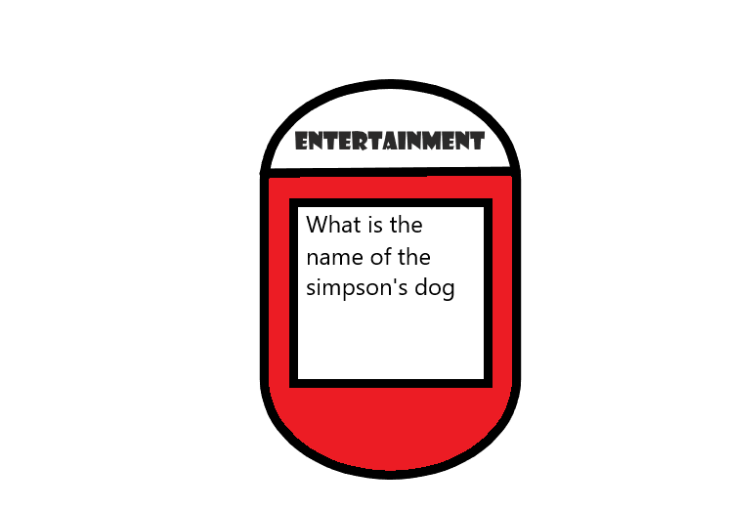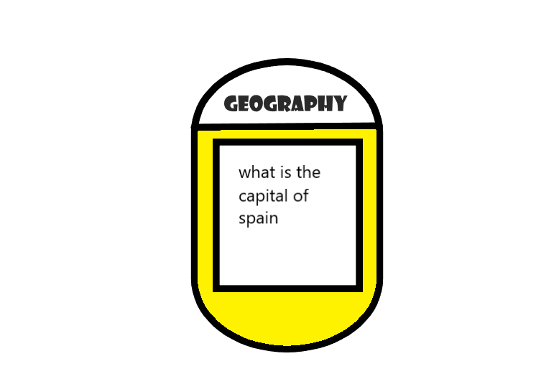

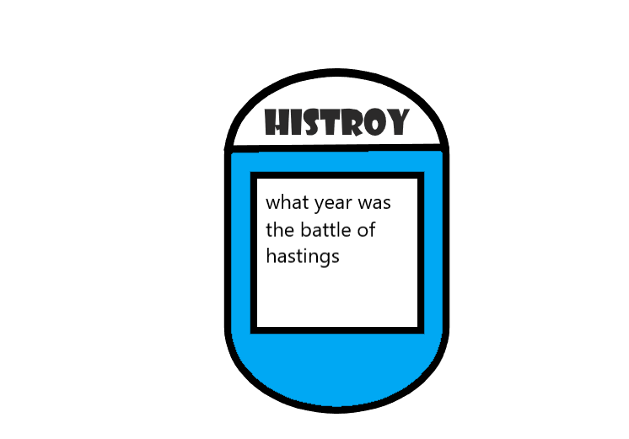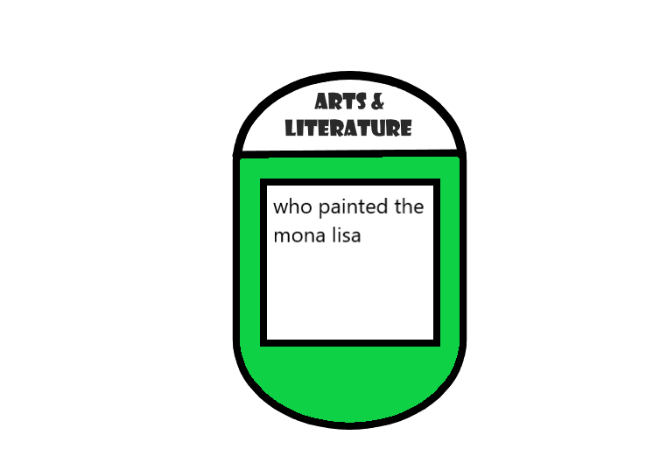

­Fig 5, Example Trivia Cards.

## Material used to make the game

We made the components for this game digitally, through the software ‘Paint’.

If this game was to be mass produced the game board designs would be printed onto vinyl stickers and then stuck onto a scored binding board that would enable the board to be foldable to easy storage.

The game tokens would be made from plastic.

The trivia cards would be printed onto gloss coated card stock to allow for an aesthetically pleasing finish.

The game board, tokens and trivia cards would come in a nice quality carboard box with a design printed onto gloss paper on top.

## Rules and Mechanics

* The game is played in 2 to 4 teams.
* At the start of the game the teams roll a D6 dice to decide who goes first
* Each team will have a designated shaped token to identify the spaces they ‘own’.
* Teams take it in turns, once one team has answered a question correctly/ failed at answer a question it then moves to the next teams turn.
* The first team to have three tokens in a row win.

## How the game is played.

As the teams play the game when they want to place a counter on an available space, they are required to roll the dice with each number of the dice relating to a different trivia category. A member of an opposing team will then pick up one of the trivia cards from the category decided by the dice roll and read the question to the team who rolled, any player in that team can answer and if they answer correctly they get to place their token down on the space, if they answer incorrectly they don’t place their counter down.

­­­

Fig 6, Game Play – Yellow Triangle Won Round.

## Play Testing

Play Testing was carried out internally within the design team. The game functioned as intended as players were able to take turns in order – player with highest dice roll went first – and answer questions from a random chance mechanic when they rolled the dice.

During play testing, players found that the questions from an online trivia generator were too difficult and this resulted in players guessing answers or skipping questions. Because of this, the game becomes prolonged with little activity happening on the board. To reduce this issue, a steal mechanic was introduced to allow for players to answer questions if the other player is unable to and allow for easier questions to be introduced and asked.

## ­Experience working in the team to problem solve.

During this session my team collaborated well in order to produce this game. Once we had a premise, we were able to further develop the idea and everyone was able to add valuable input that aided in improving the game development.

## Team members.

Joshua Wye (Me)

Brennon Franklin

Tony Hoang

Ben Miller

585 Words without Fig headings.

## List of illustrations

Fig 1, Game Tokens.

Fig 2, 6x6 Game Board.

Fig 3, 8x8 Game Board.

Fig 4, Trivia Categories.

­Fig 5, Example Trivia Cards.

Fig 6, Game Play – Yellow Triangle Won Round.